through learning - RoboWorld

  - Masaryk elementary school
  - Kamenačky 4/3591, Brno – Židenice
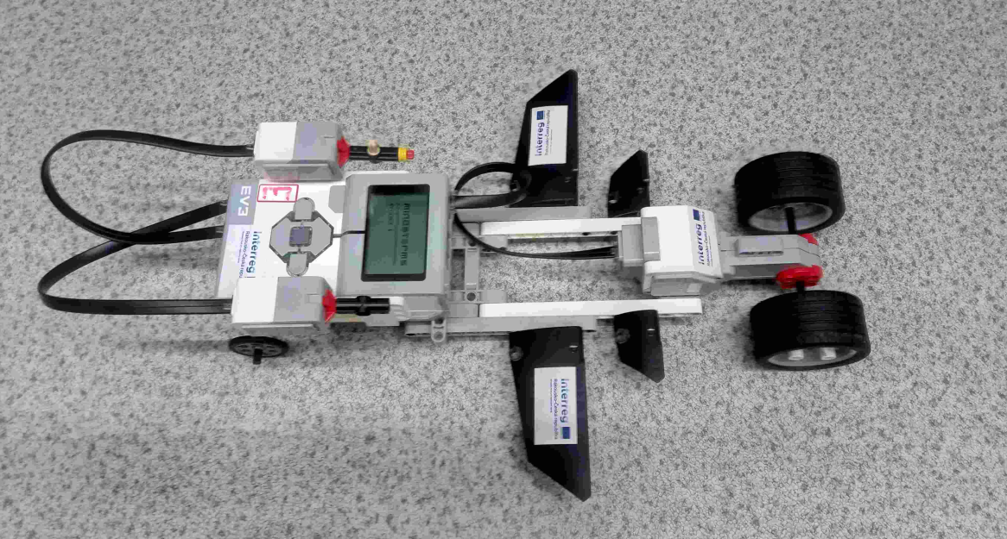
Contents:
About the project at our school 3
Robotics for the youngest - 1st to 4th grade 3
Robot Bee – Bot 3
Good to know 3
Hands-on exercises with Bee-Bot: 5
Robotics for 5th to 7th grade 9
Lego WeDo 2.0 9
Good to know 9
Practical exercises with Lego WeDo 10
Robotics for 8th and 9th grade 16
Lego – EV3 Classroom 16
Good to know 16
Practical exercises 17
Conclusion 23

About the project at our school

The goal of our project was to test the acquired technique with skilled pupils. Try to define basic tasks that can be applied in teaching. Describe these tasks at least in a basic way, so that they can be implemented in a normal teaching environment. In the first part of this document, we present information about the Bee-Bot robot, which is intended for the smallest children in first to fourth grade. Older children from 5th to 7th grade could work with Lego We-Do, which is significantly more complex and requires better cooperation with the computer. The last part will deal with working with the LEGO EV3 Classroom edition, which we used with 7th to 9th graders. It is necessary to realise that the school lesson is only 45 minutes long, so working with EV3 is considerably limited by this.
It is necessary to express gratitude for the opportunity to participate in the project of the European Union DigiMe Interreg Austria-Czech Republic. We could not afford to purchase the material provided. We have thus gained valuable experience and now it will be much better included in the teaching. The robot club continues.

Robotics for the youngest – 1st to 4th grade

Robot Bee – Bot

Good to know
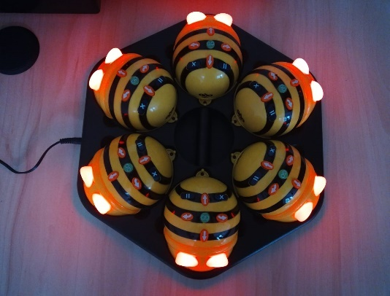
With its simple design, the Bee-Bot is a great tool for teaching control, direction and programming. Together with the Bee-Bot, it is advisable to use mats on which it can move. The mats are either pre-prepared from the manufacturer, or you can use a transparent mat with your own cards under the mat. There are also other accessories for the Bee-Bot, such as a pencil holder. This additional accessory expands the possibilities of working with the robot and brings new challenges for children.
Bee-Bot takes "steps" of 15 centimetres and can turn 90° at a single command. It remembers up to 200 steps at once. After each use, I recommend recharging it to preserve battery capacity. Caution when entering steps, it is necessary to be aware that new steps/instructions are added to already existing instructions. The chain of steps always starts from the beginning on startup.

Even four-year-old children enjoy working with this robot. However, we must point out that they tend to drive the robot like a car. We definitely do not recommend driving the robot like a toy car in any way, it could damage the robot. If we move the robot, we always pick it up and carry it. Older children will already be able to move the robot around like a toy car, but be careful, it is still necessary to supervise what they are doing with the robot.
For other practical exercises with the robot, it is advisable to use your own, pre-prepared "tiles" (printed images according to your needs and suitability). Before starting working with the robot, we will prepare them under the running mat according to our own discretion. A self-made sliding mat can be easily made from old protective Plexiglas for a table, whose edges are sanded.
I looked up the contents of the tile on the internet as simple black and white images. So after use, we could leave them as colouring books for the children. I recommend making the tiles circular and smaller than 15 cm in diameter. A small displacement during use does not matter and is not so disruptive. The tile looks better with a border. At the end, we attach a printable pattern.
As a running surface for the robot, apart from the one offered by the manufacturer, it is possible to use any plastic film or board that is transparent. Measurements are up to us and what we get. I recommend drawing the square grid with an indelible spirit/marker on a CD so that it does not rub off. The length of the side of the square is 15 cm.
It is possible to use foil on the images, but it cannot be assumed that the robot will then drive over them without a travel foil or other integral solid surface. This must always be used for smooth use of the robot. (Tested, the front "wheel" often picks up the image and pushes it in front)
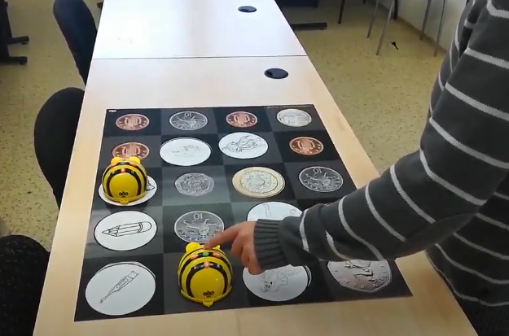
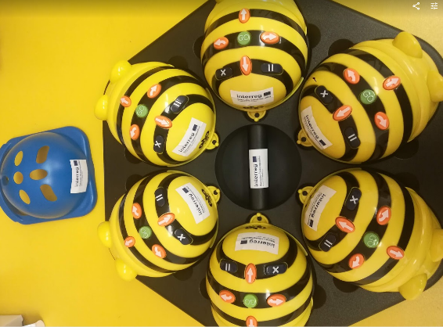
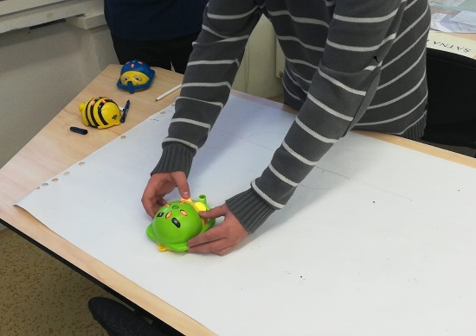
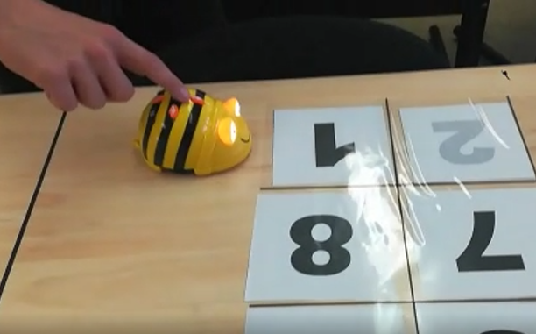

Hands-on exercises with Bee-Bot:

- Along the trodden path – Under the transparent mat, I will prepare pictures with arrows of forward, turning and backward movement. I stack them under the mat to form a path for Bee-Bot. The children have the task of programming the robot to set off along a path prepared by us.
- The child sees how the robot reacts to his instructions and sees a practical example of the cause and effect of his actions.
Extension: Children prepare the path for the robot with each other.
- Number/colour ride – I will prepare pictures with numbers under the transparent mat. The children program the robot to follow the numbers one by one. I recommend making the numbers in different colours and then you can practice them. (Choose darker and more saturated colours in their shades so that they are clearly visible after printing)
Extension: To determine the next number where the robot should go. We can also use a dice roll
- Getting to know animals – Suitable for the little ones. The child programs the robot to run over the chosen animal. Then we will talk about what kind of animal it is and what sounds it makes and something interesting.
Extensions: A plethora of themes can be used in images. According to the children's preference.
For example: dinosaurs, vehicles, toys, first aid items, household appliances, fruits and vegetables, trees and herbs, etc.
- Maze – We will place obstacles for Be-Bot on a square grid. We block the selected fields on the square grid with any suitable object. We will determine the beginning/entrance to the maze. And then we choose/the kids choose the target tile. The goal is to program the robot so that it reaches the selected tile and does not destroy anything on the way.
Extension: A similar board block can be used as a supplement to the above exercises.
- We travel with Be-Bot – You can put a map under the travel film. (I had a map printed on a plastic sheet at my disposal. I just drew a square grid) We then send the robot to different places on the map. From the city, he will go to the field, then to the forest, and then to the neighbouring village.
- Let's draw with Bee-Bot - The Bee-Bot robot can also be purchased with a drawing attachment. We simply put the attachment on the robot and insert the writing tool into the front holder. A fix worked better for us. As there is almost no pressure from above on the marker/pencil. You need to choose something that writes easily and well. More like a thicker soft pencil than a thin and hard one. More like a marker than a pen. Although be careful when using a Marker as it can soak through the paper. It is also advisable to seal the writing tool in the holder. So that it doesn't "gargle". A piece of paper or adhesive tape is enough. If there is too much slack in the holder, the marker tends to jump around and then miss when drawing. You need a large piece of paper and a lot of space.
Sample drawing with attachment:
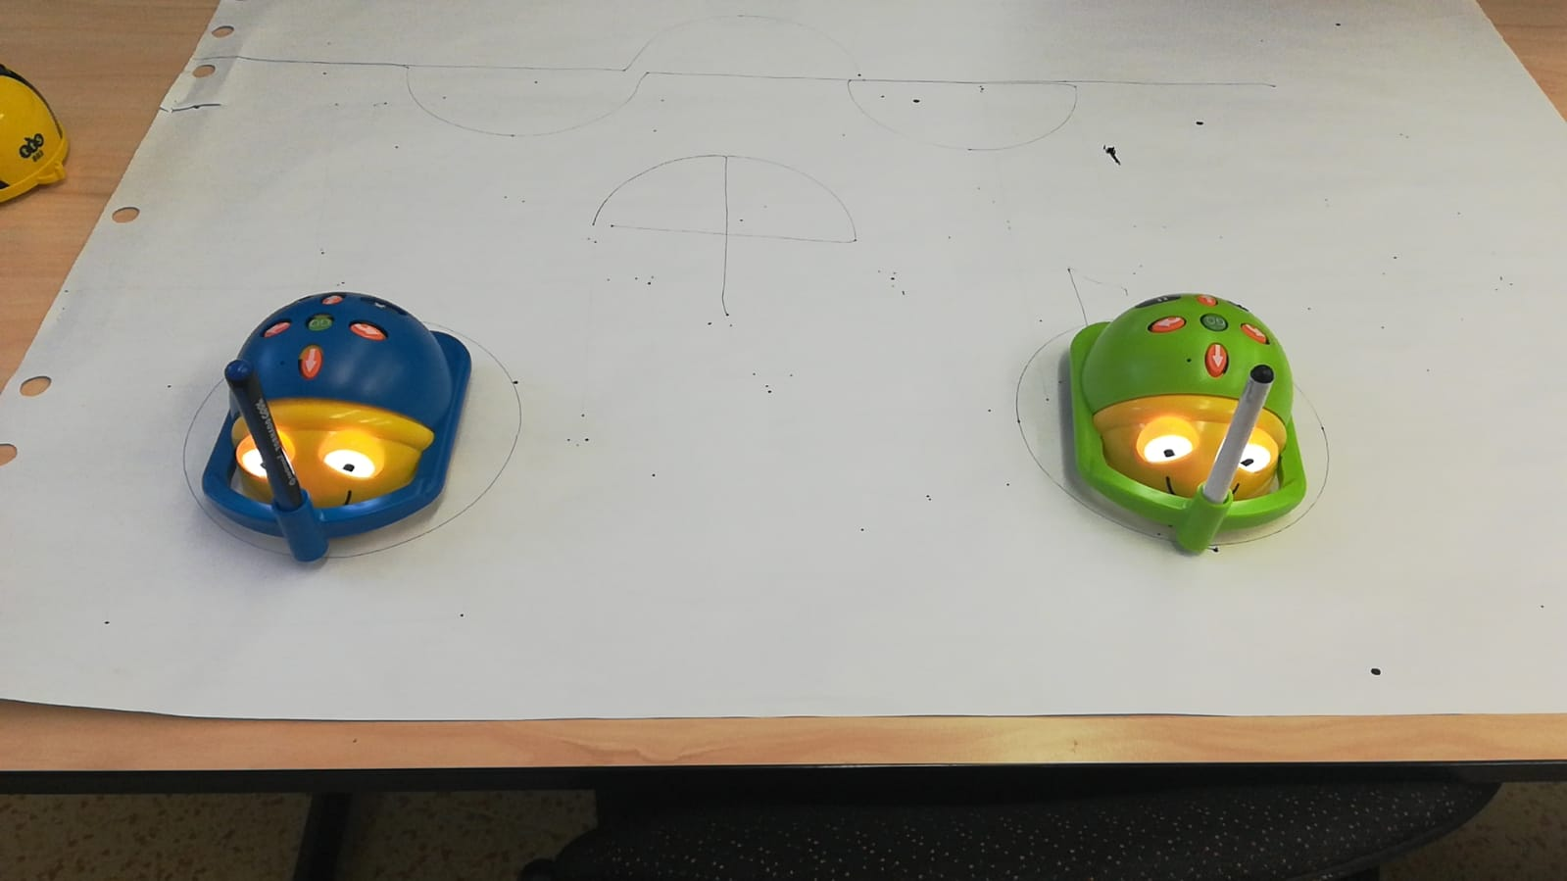

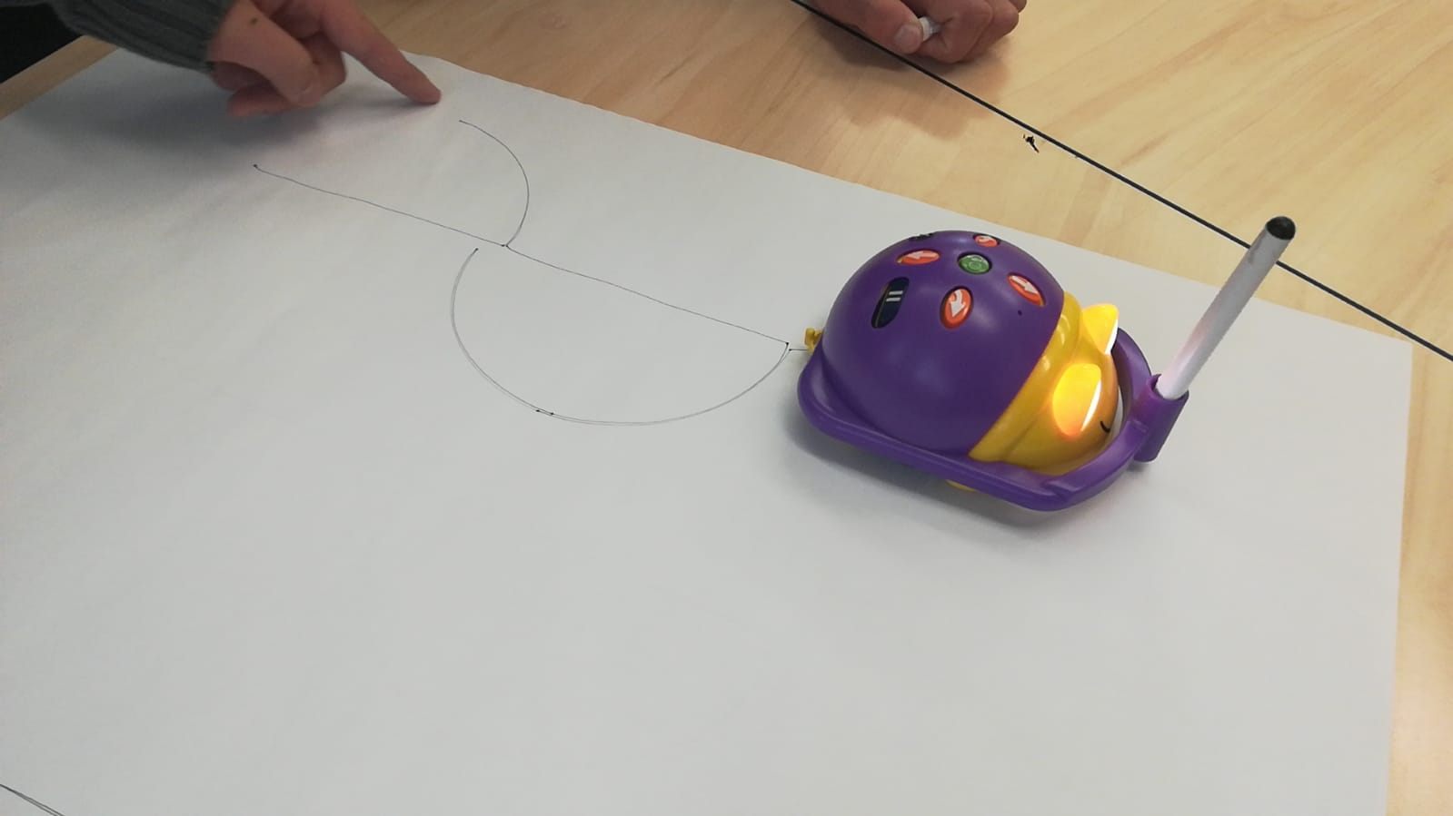

Sample tile:
Images need to be copied into a blank document and the edges of the print moved. This will get the images on the page and in the correct position for printing. The internal images can then be easily changed.

Robotics for 5th to 7th grade

The previous chapter was devoted to the Bee-bot robot, which is intended mainly for smaller children. It is mainly focused on the sequence of commands and their entry is very simplified to the connection of several consecutive button presses. While older children in the 5th to 7th grade already manage, according to our experience, to work effectively with the computer and the robot, they use the PC to enter commands into the robot. For this reason, we chose Lego WeDo 2.0, which combines both computer control and block diagram programming assistant, as well as creative creation in the form of creating a functional structure from Lego bricks. It is appropriate to point out that in our school we also work with the Mercury kit, where pupils create their own constructions using this kit. So we have a positive experience that both boys and girls can create a structure that meets the basic design requirements and at the same time use their own imagination. So we allowed ourselves to leave a large part of the imagination to our students.
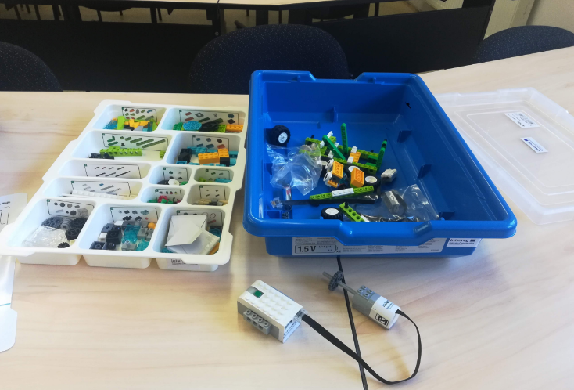

Lego WeDo 2.0
The set contains 280 building elements of the LEGO system. The most essential part is the smart WeDo 2.0 Smarthub, which can work with additional inputs or outputs via two ports. An interesting part is the built-in RGB light point, which can work with up to ten colours. The Smart Hub can be controlled via an app or software that is connected via Bluetooth.
The middle motor is capable of basic movements forward, backward. We can regulate its speed, direction of rotation and number of steps. The motion sensor is able to detect movement and thus react to stimuli, for example hand waving. The tilt sensor then reacts to a change in position, for example when the trolley comes in contact with an obstacle.
Self-adhesive label and plastic sorting tray.

Good to know

Unfortunately, the kit is no longer produced these days. Unfortunately, according to our information, this is true. However, LEGO has come up with a new type of kit that is sold under the name LEGO Spike Prime. Our school managed to acquire this kit from another project, and based on our short experience, we can judge that it is a more developed replacement for WeDo. It contains more specific cubes and thus allows you to better use your own imagination. The controls are more similar to the EV3 Classroom lego, so it is easier for children to subsequently switch to a higher model. The advantage is also a computer-free solution, when after connecting the motor and to the opposite point of the sensor or button, the motor speed can be regulated.
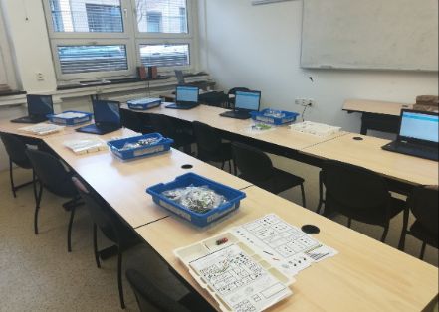
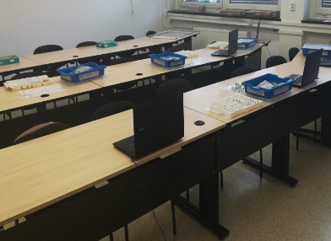
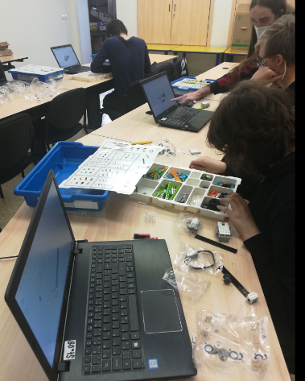
Lego WeDo is suitable for use in combination with tablets and notebooks. In our case, we used notebooks that our school purchased from the Templates II project.
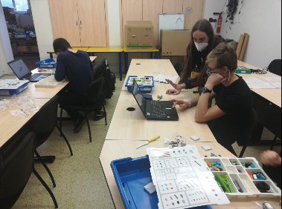
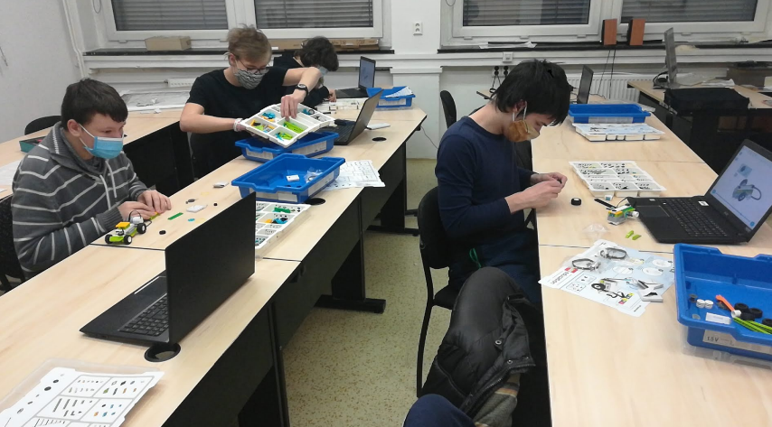

Practical exercises with Lego WeDo

Considering that LEGO has relatively well-made models within the control program WeDo 2.0, we decided to try only some manuals in order to have a basic experience. Subsequently, we threw ourselves into our own work. We managed to assemble and put most of the manual constructions into operation in a time significantly shorter than one lesson. It should be noted that our experimental students were 8th and 9th graders. So let's take a guess that the younger children's constructions would take longer, but if the children work in pairs, they should be able to complete the constructions together in one hour under classroom conditions. At the time of school closures due to COVID 19, we were able to work with family members of teachers that are 5th graders. The time to assemble the models was faster than the predicted 45 minutes for these children, but we believe that this speed was largely due to the pleasant home conditions.
- SNEAKER MODEL – Light signals in a loop
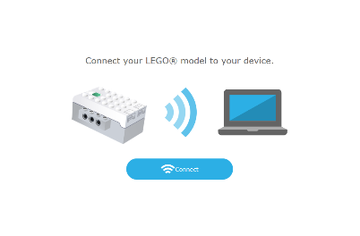
According to the instructions or their own imagination, children build a simple snail. It is possible to use the WeDo 2.0 manual included in the program. Subsequently, the cube needs to be connected to a notebook or tablet using Bluetooth technology. We recommend using the instructions included in the software. We will compile a simple program where we drag other elements behind the green triangle. We thus compose individual commands for each other. After dragging the colour scale, the option to choose the colour that the diode will light up will pop up. You can also get to the colour selection by clicking on the number below the colour palette. More clever children can use the loop and the colours of the snail will repeat in the specified amount after sending it to the cube. The figure shows 12 repetitions
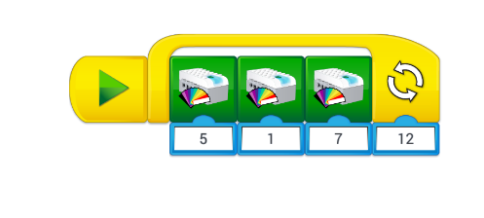
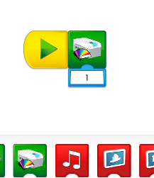
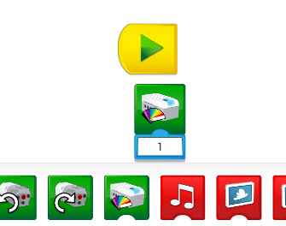

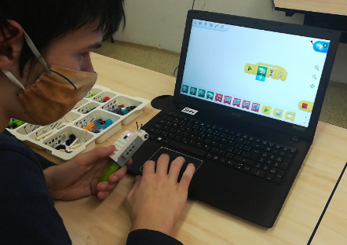
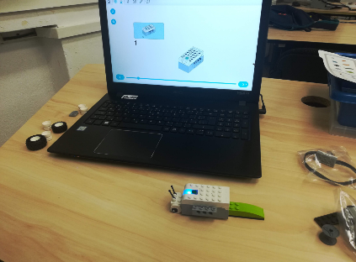
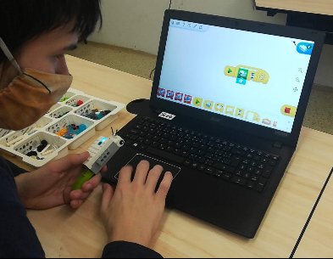

- Snail with sounds
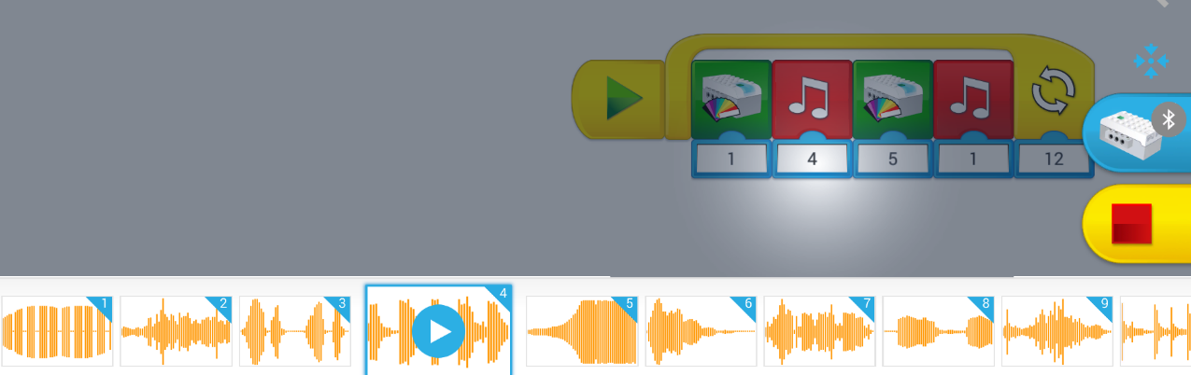
In the same way that we changed the colours, we can also adjust the sound. Students are tasked with choosing at least two sounds that will follow each colour. Note that the bottom selection bar can be moved to the right and left.
- Mill / fan
We will again use the LEGO WeDo 2.0 manual for construction. Subsequently, we work with the project as follows:
  - motor movement – in block programming, we assign motor settings to a chain. It is possible to supplement the program with colour signalling before starting. After moving the motor, I set its rotation speed on a number line from 1 to 9
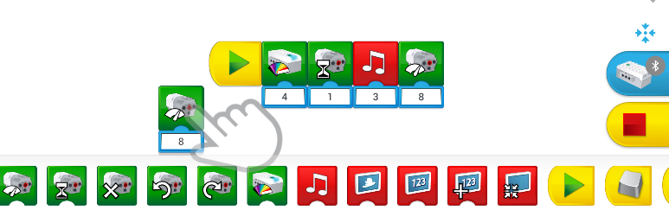
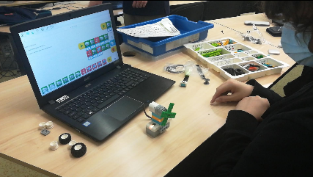
  - safety mechanism – addition for smarter children. The tilt sensor plugs into the main cube next to the motor. We place it on the fixed part of the mill behind the propeller. The program will then look like this:
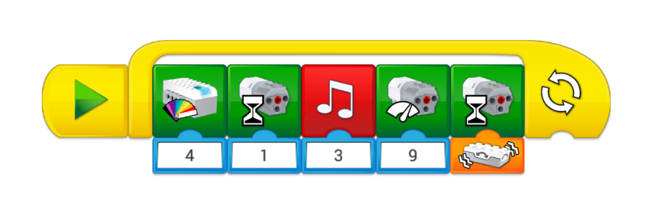
- Satellite – settings for forward and reverse motor movement
Build a simple satellite according to your imagination or according to the instructions. The wheel at the end of the arm will be used to rotate it around the axis. Use both directions of motor rotation when working with the program. Insert a waiting time between each direction of rotation.

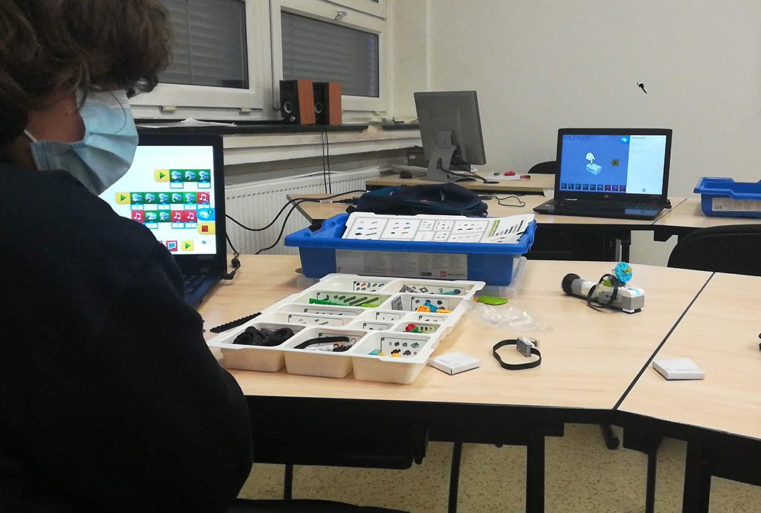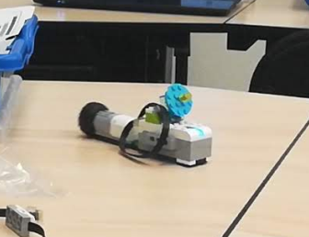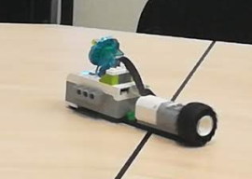
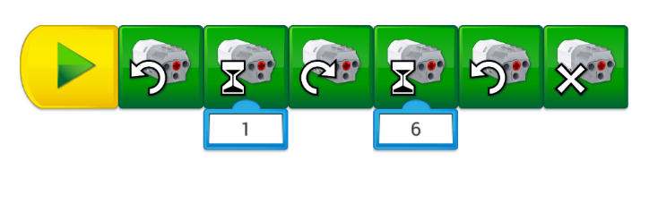
- Little car
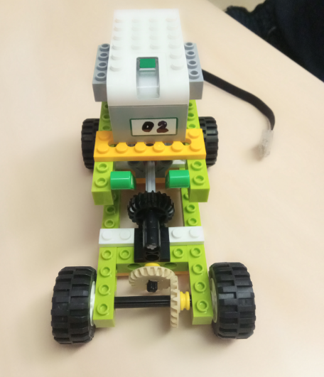
According to the attached picture or according to your own imagination, build a toy car that will have a rear axle drive. Use either gears or rubber bands to transfer power from the engine to the bike. You can find examples of buildings below. You can see in the lower right, the technology of offset wheels is used - you can see it better in the video.
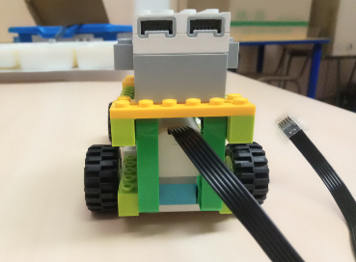
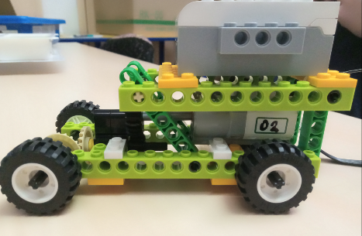
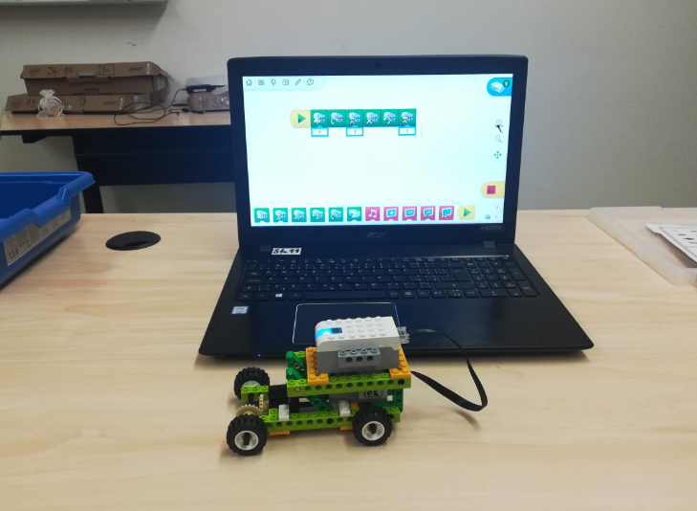
Variant with rubber transmission:
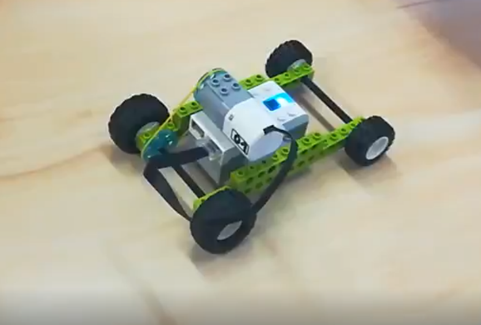
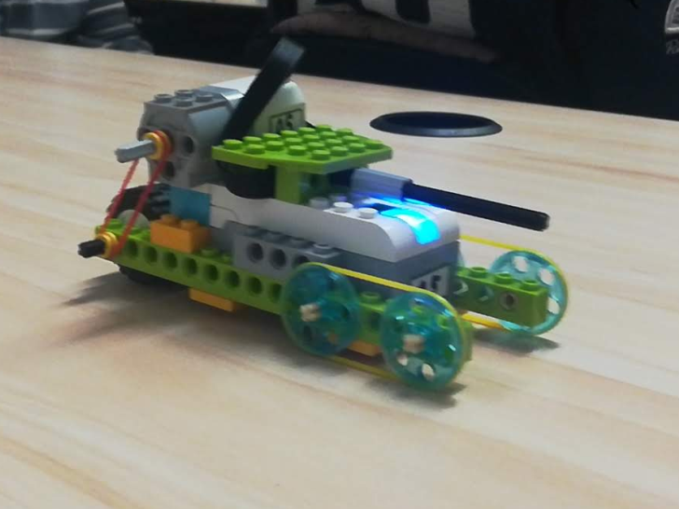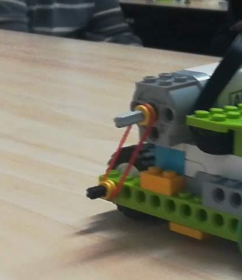
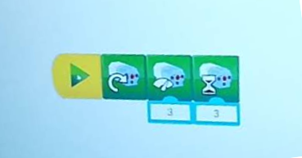
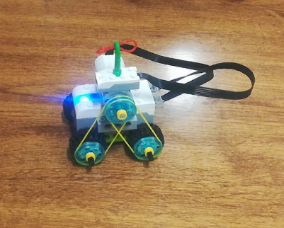
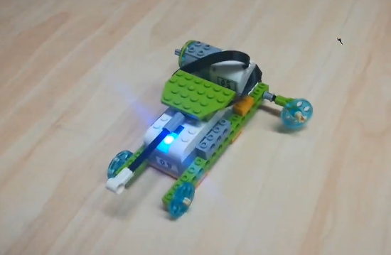

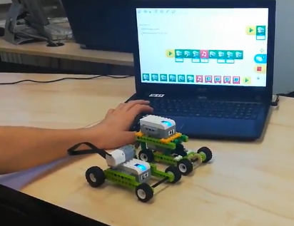
- Car racing
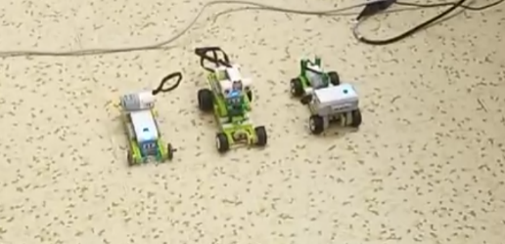
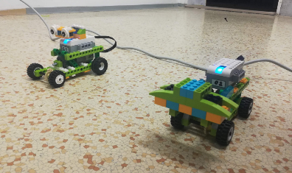
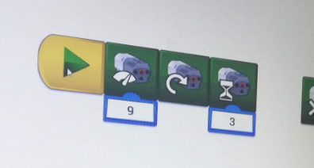
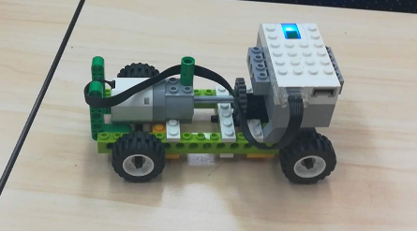
We will place the toy cars made in the first part against each other at the start. We measure which car has better acceleration and which one goes further in a timed driving time. We will try to justify the results logically and, based on the experience gained, we will try to assemble the best form of the car. We will explain that the transmission of energy using rubber bands is more lossy. Next, we will point out the weight distribution on the vehicle. We thus connect physics with robotics. Children gain the opportunity to think critically and look for solutions that they can test themselves within a few minutes. It is necessary to create a uniform control program for all racing vehicles.

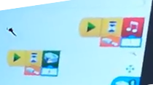
7. Motion sensor
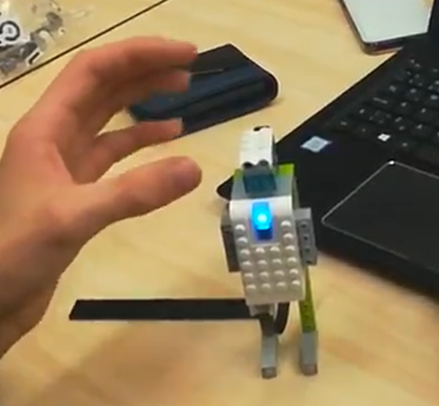
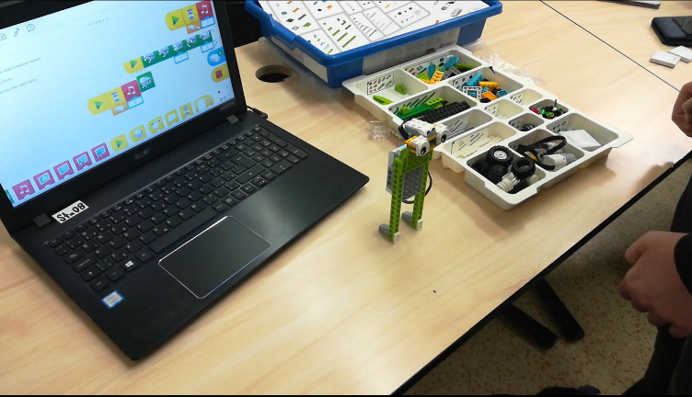
Using the pattern in the program or according to your own imagination, create a robot character that will have a motion sensor attached to the upper part of its body instead of eyes. At the moment when the sensor is covered another light will turn on and the ones that are more skilled can also program the sound of a tone.
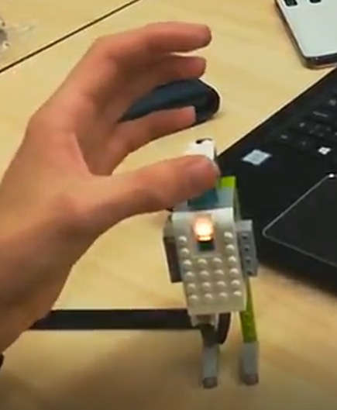

- Mobile helicopter – the highest difficulty
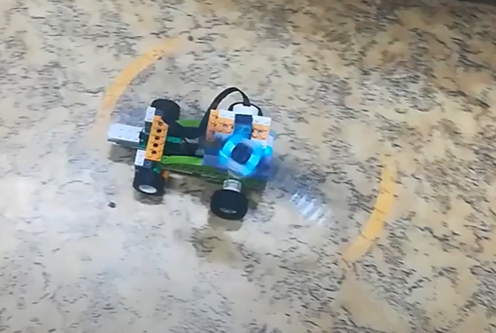
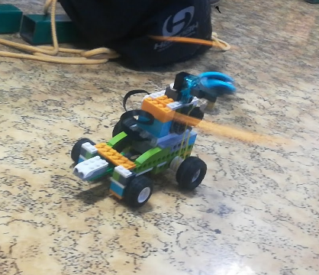
In this case, we combine a rubber belt transmission with a gear wheel to which the propeller is attached. Children must therefore find their own technical solution to fix the propeller and at the same time maintain its functionality and connection to the engine. The entire structure has a distance sensor connected to the second port, which will start backing the car away from the obstacle. It is better to see the situation in the video.

Overall, we can say that LEGO WeDo met our expectations and we are happy to work with it. Pupils work on their technical creativity and at the same time have to comply with the laws of physics, which they put into practice. Thanks to the connection via Bluetooth, we were able to implement programming even during distance learning, which was quite interesting in itself. For completeness, I am attaching a few photos of the LEGO Spike kit that is currently replacing WeDo. The robot is capable of moving along a line, but only if you use another sensor from the second kit. Programming in blocks is more like EV3 and SmartHub has the same shape. The display works somewhat differently. However, most of the buildings listed by us can also be realised with this kit.
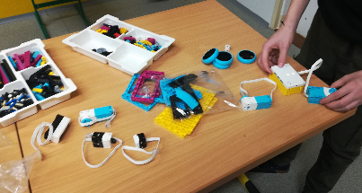
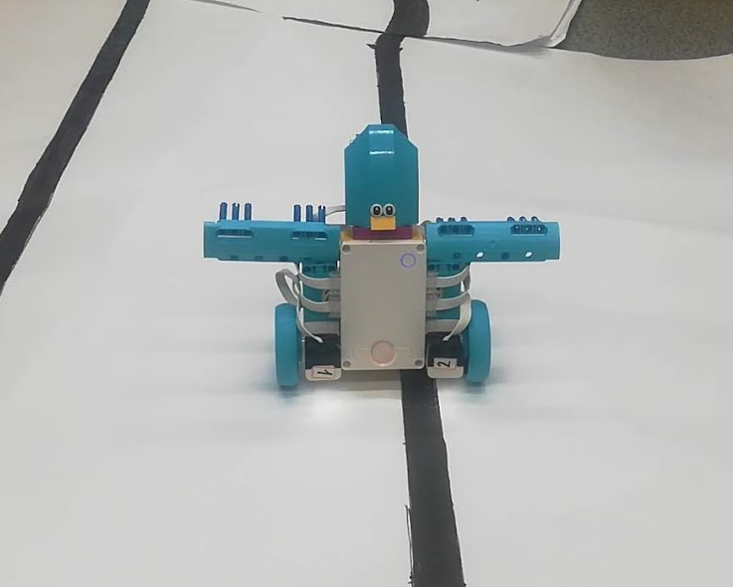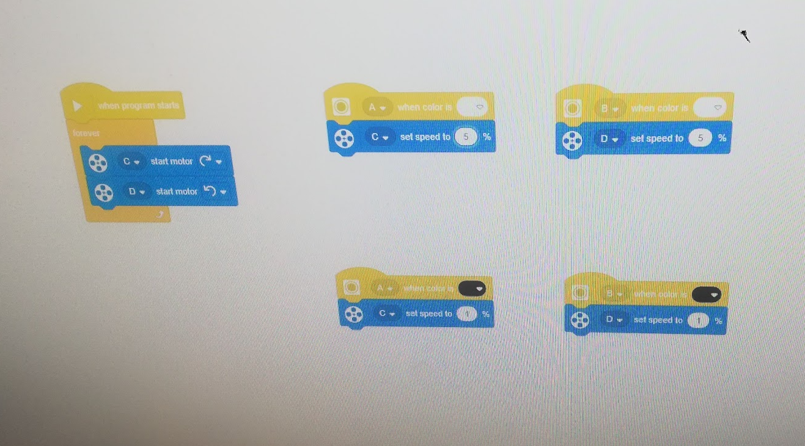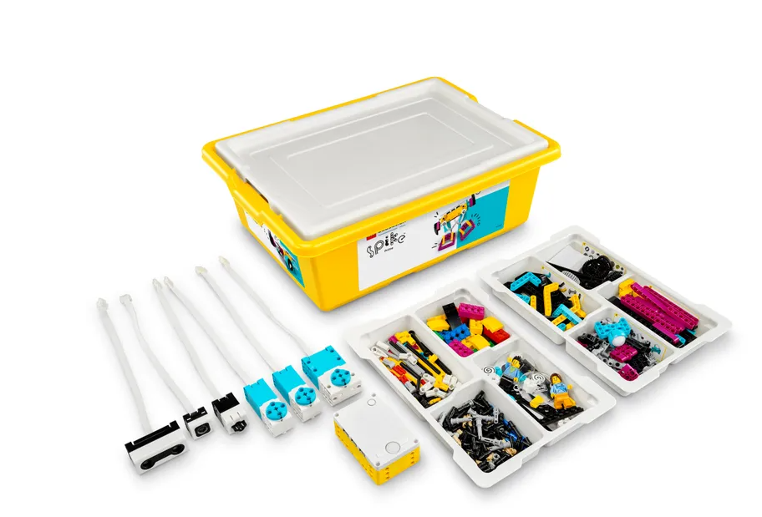

Robotics for 8th and 9th grade

The previous chapter worked with an already more advanced robot named Lego WeDo 2.0, now we will move even further, more precisely to the LEGO EV3 robotic kit. We chose this sequence based on the expected difficulty of working with LEGO EV3. We worked mainly with our own imagination. Our goal was not to blindly copy and just try already invented robots. The goal was and is to create topics that can be implemented relatively easily within a regular informatics class.

Lego – EV3 Classroom

This is the most advanced version of the LEGO robot kit. The basic package includes a SmartBrick – a cube containing a control unit. In addition, three motors, two push-button switches, a colour sensor, a distance sensor and a motion sensor. The entire package is stored in a two-story box, while in the good part we can find a folder for parts. Our package also includes a rechargeable battery that usually lasts for several days of use.

Good to know

SmartBrick also allows you to control it purely using buttons, so you don't need to connect it to a PC, tablet or laptop. Unfortunately, this action limits you to only the simplest motor control. You can find an example of this procedure in the video. It is also good to know that in case of distance learning, for example, you can enable students to control your school laptops directly from home via the installed MS Teams application. During distance learning, the students programmed via a "remote desktop" on a school laptop that was paired with one of the robots. So we could hold tournaments for the elimination of the enemy or the best dance creation that will last exactly 23 seconds. Thanks to this solution, two important projects for the school, namely DigiMe and Templates II, were connected.

Practical exercises

Lego EV3 is suitable to have in the number of one piece in a pair. In our case, we have always divided the work. One of the pair started programming and the other built. In most cases, this is how the collaboration began, but since development cannot be effectively conducted only in the theoretical field, the students themselves did not follow predefined roles, but advised each other. However, we recommend a strict division of roles, so that the builder cannot interfere with the programming and the programmer cannot build. They can only advise each other and possibly help each other. We place responsibility into the students for their own part in the project.

- Building a robot and concurrent training on make code editor - https://makecode.mindstorms.com/#editor
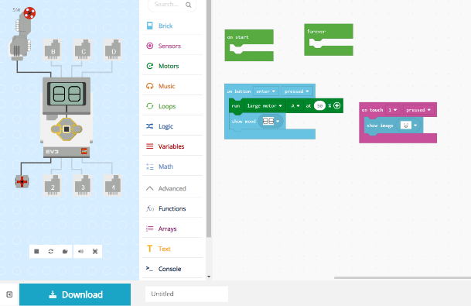
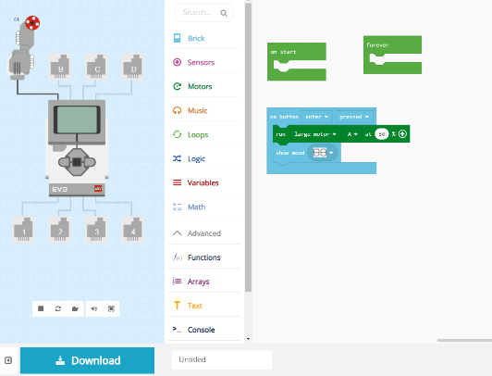
It worked for us to assign the work in two parts. The technician builds the robot and the programmer gets to know the robot in a virtual environment. The environment is quite intuitive, in the right part it is possible to assemble a program from individual blocks. Simply in the sequence as we wish. A basic knowledge of English is sufficient to operate. The goal is for the student to try out as many elements as possible from the Brick, Sensors, Motors, Music and Loop categories.
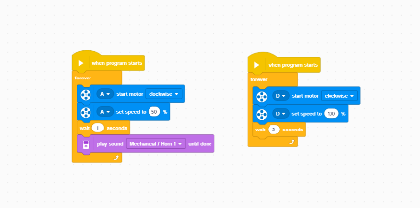
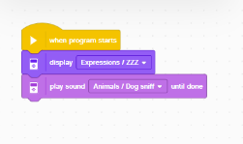
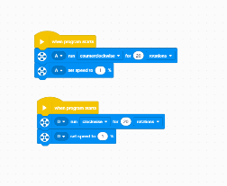
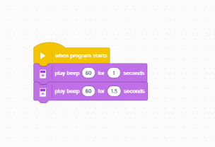

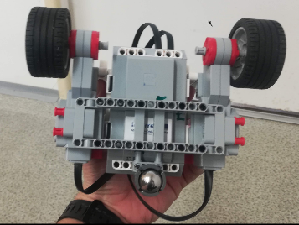
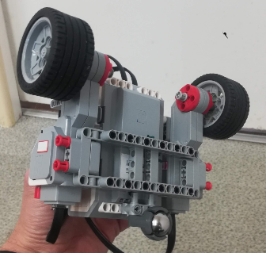
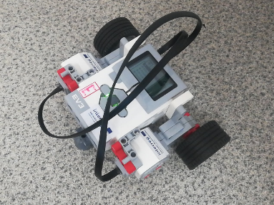
- Toy car – simple and practical. The simplest build to start with only includes two motors, a large support structure, an anti-wheel ball placed in a triangle, and a few well-placed pivots. Faster children can complete the construction with buttons located next to the motors.
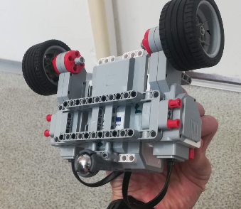
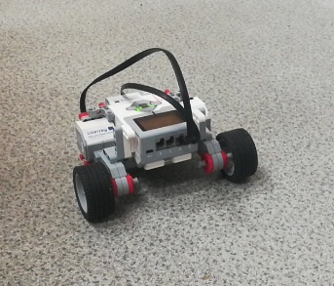
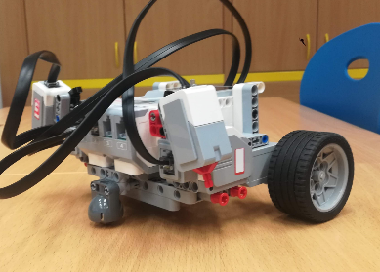
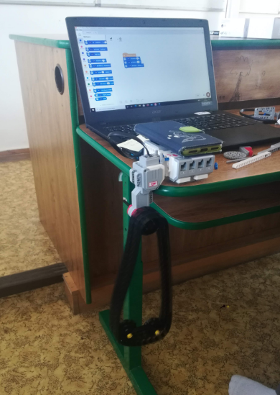
- Belt Mixer – Create a simple mixer using a belt. You have to solve the position of the engine, its attachment, control and of course the functionality of the entire system. It is convenient to explain why in the lower part the two connected wheels stay inside the loop, while the individual wheels fall out.

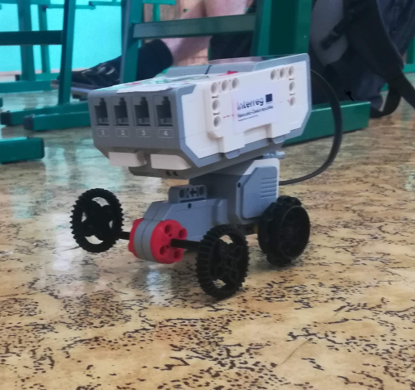

- An atypical stroller with offset wheels and one engine
Build a simple cart where with every step it wobbles as if it should fall, but it wont. Use only SmartBrick, one motor, four wheels and two axles.

- Games with robots in a limited area – a ring
With the help of notebooks, we were able to manage several hours remotely, when students sent their work to communicate and we then applied it to the robots. Thanks to the MS Teams application, we had real-time communication available and students could control two robots directly from home.
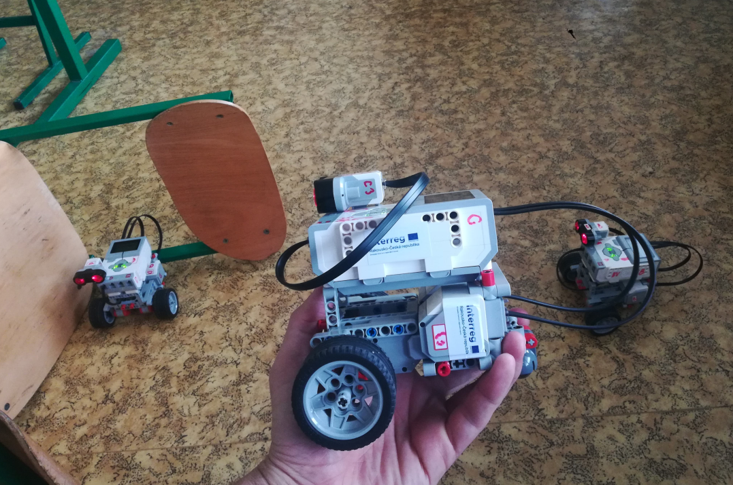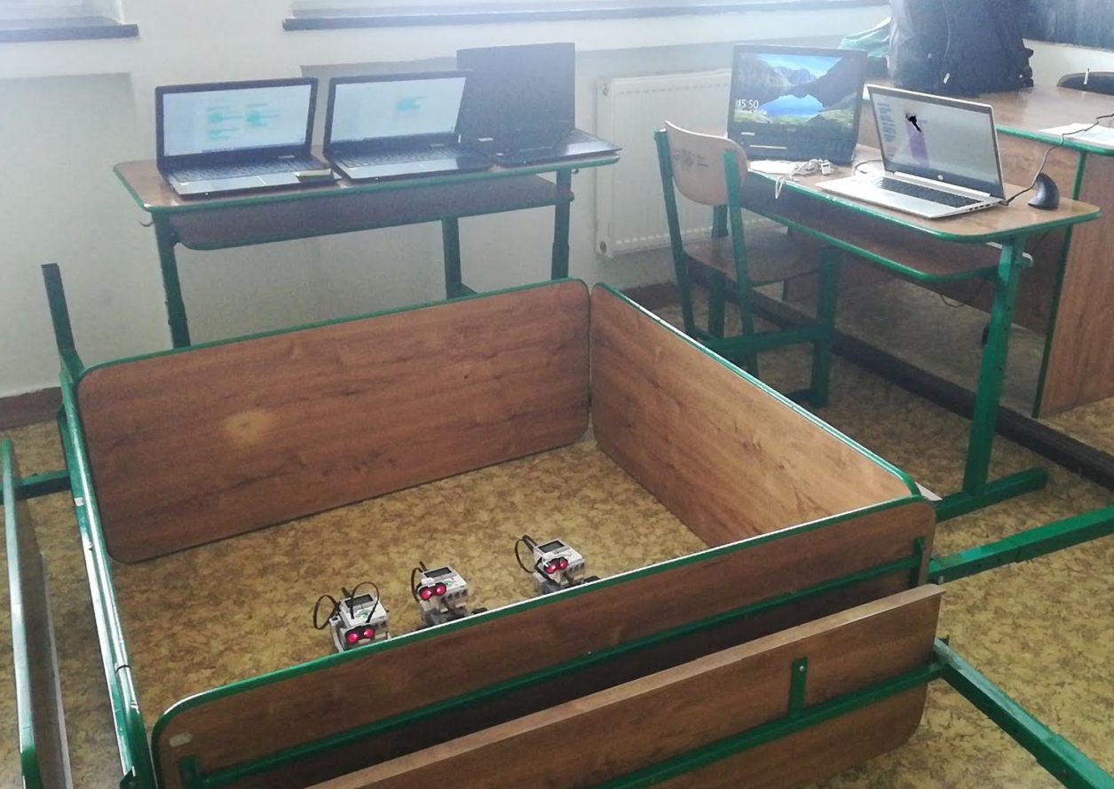
- You must not bump into – the students have the task of programming the robot so that, with the help of a distance sensor, it can stay in a closed space for as long as possible, keep moving and not bump into. The minimum displacement is 3 motor steps.

- Get behind your opponent – the goal is to program your robot so that it lasts as long as possible on wheels and best gets behind the opponent's back, i.e. for the distance sensor. Pupils can repeatedly change the program as needed - this is also one of the tactic
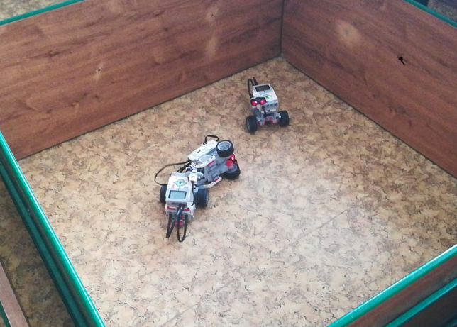
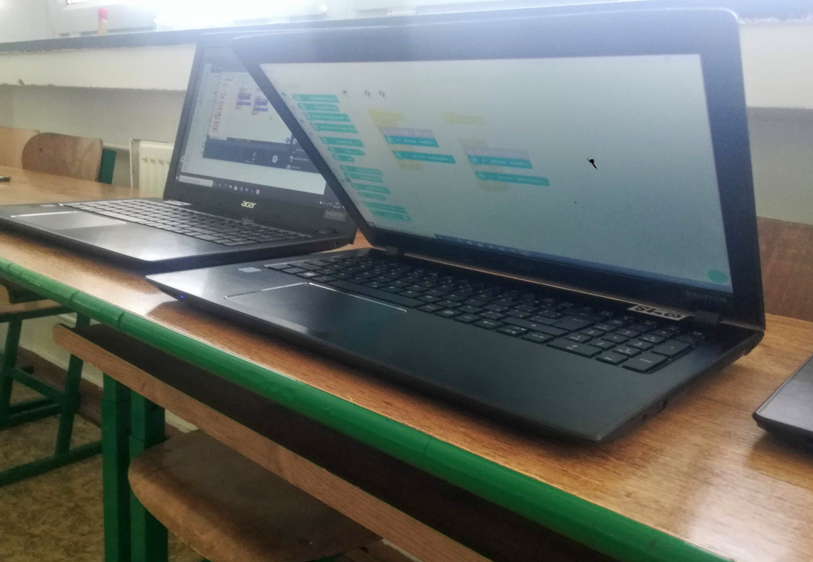

- Frightened dancer on button
Create a machine that goes faster than regular motorbikes – so you have to use gears. When you press the button, the motors will start and the robot should start to "dance" around in spirals. This is caused by the slip caused by the off-centre rear ball. We recommend building on previous chassis.
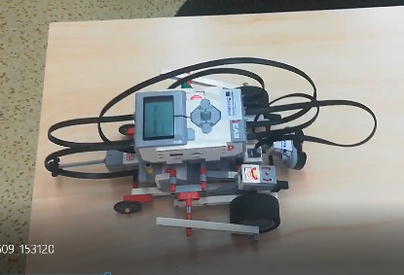
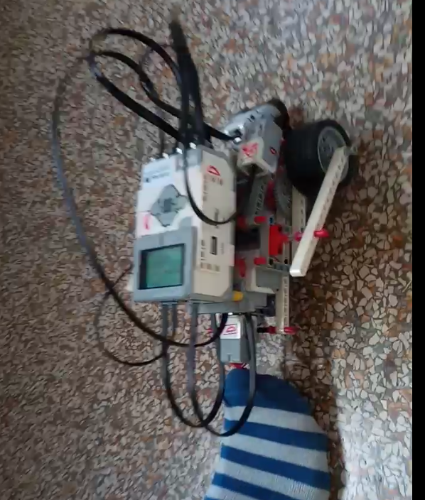
- Motorcycle – Create a working motorcycle model. A heavier option is a motor on each wheel. I must use synchronised engines. A simpler version is with only one engine, which you can find in the EV3 manual.

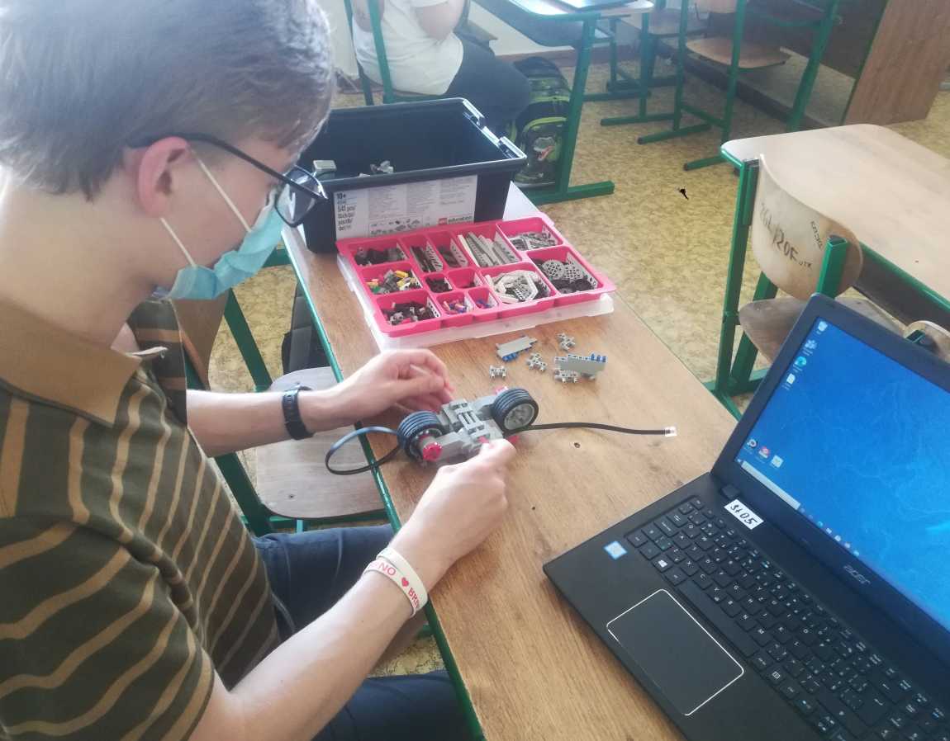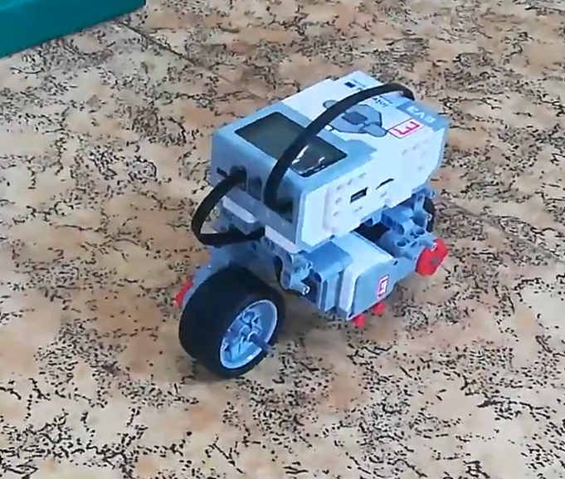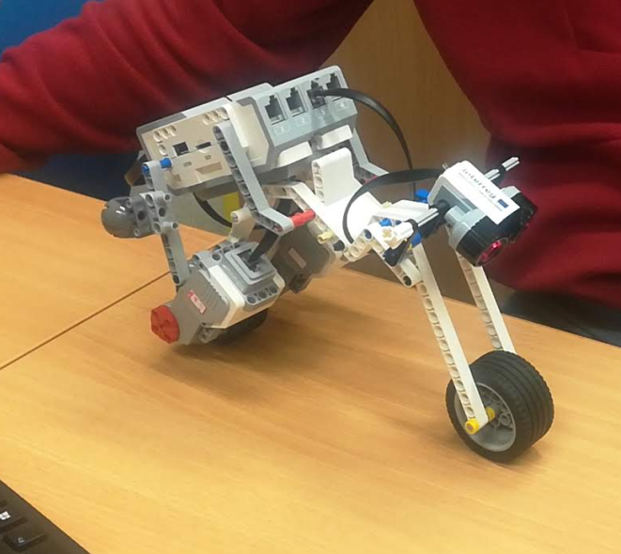
Tracked vehicles – practice driving forward, turning, creative technical solutions.
  - Simple single engine - straight forward
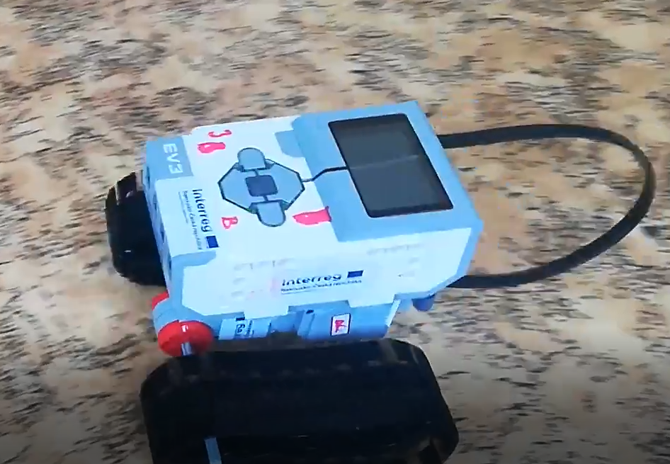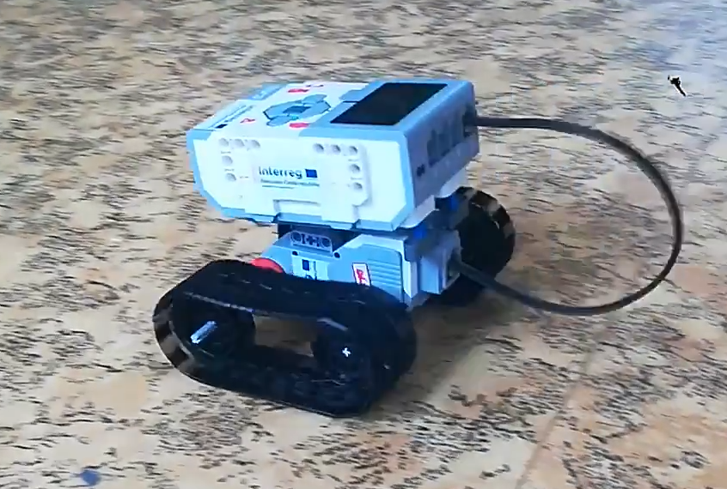
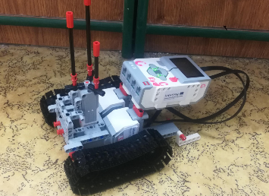
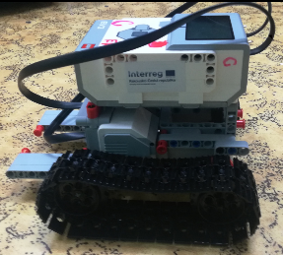
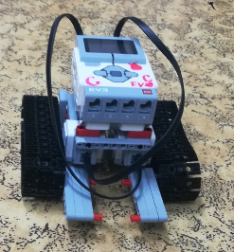
  - Engines – Create a tracked vehicle that can change direction
  - Twin engines – only one direction of travel - failed attempt to climb stairs
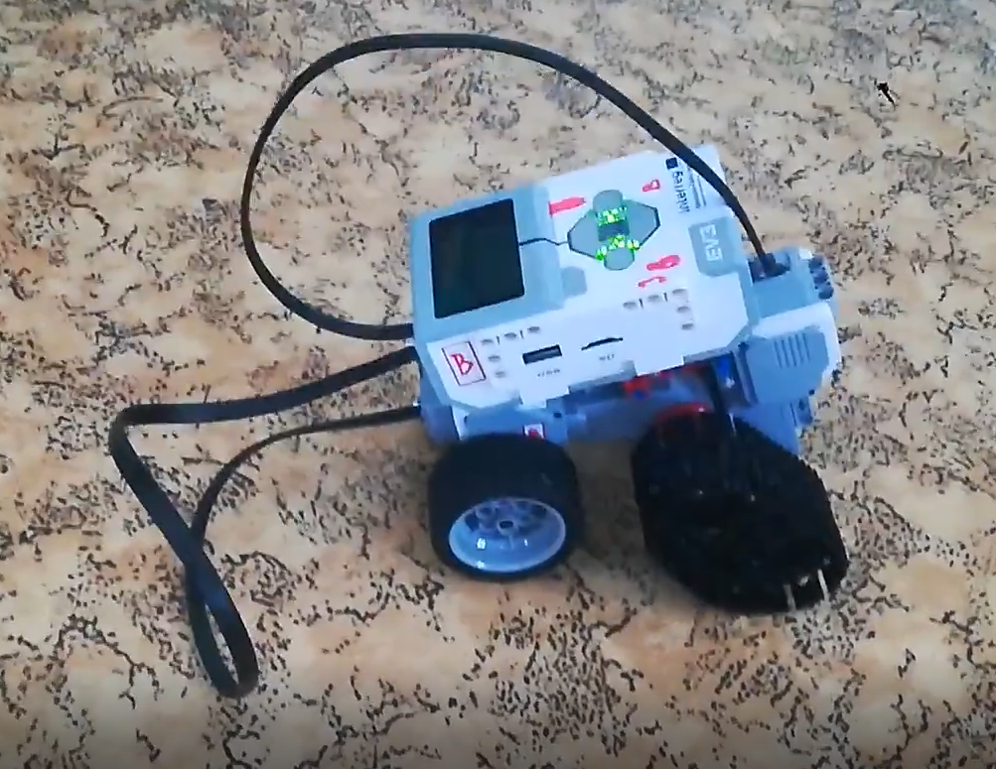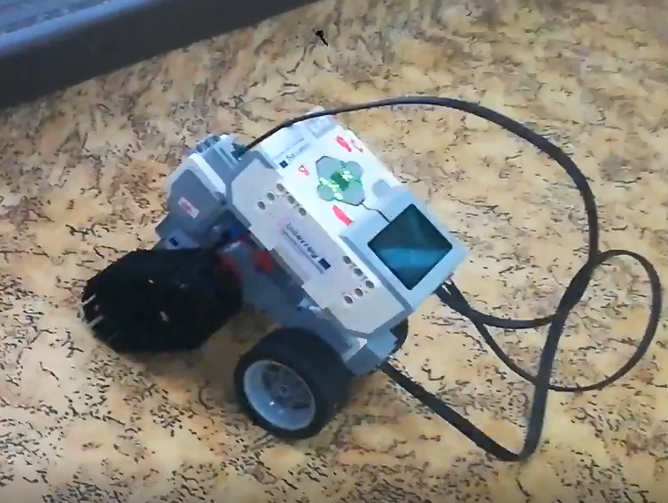

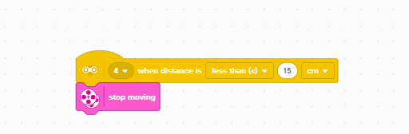
- A car with a brake before an obstacle and subsequent reversing
Create a car that automatically stops and reverses when it detects an obstacle. Use the distance sensor settings.
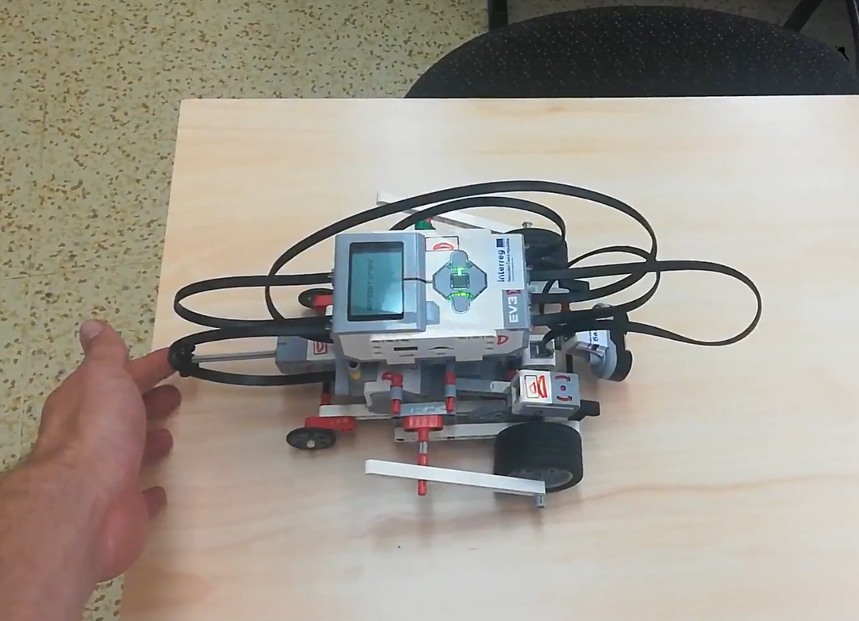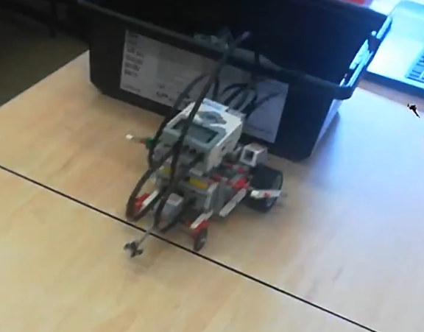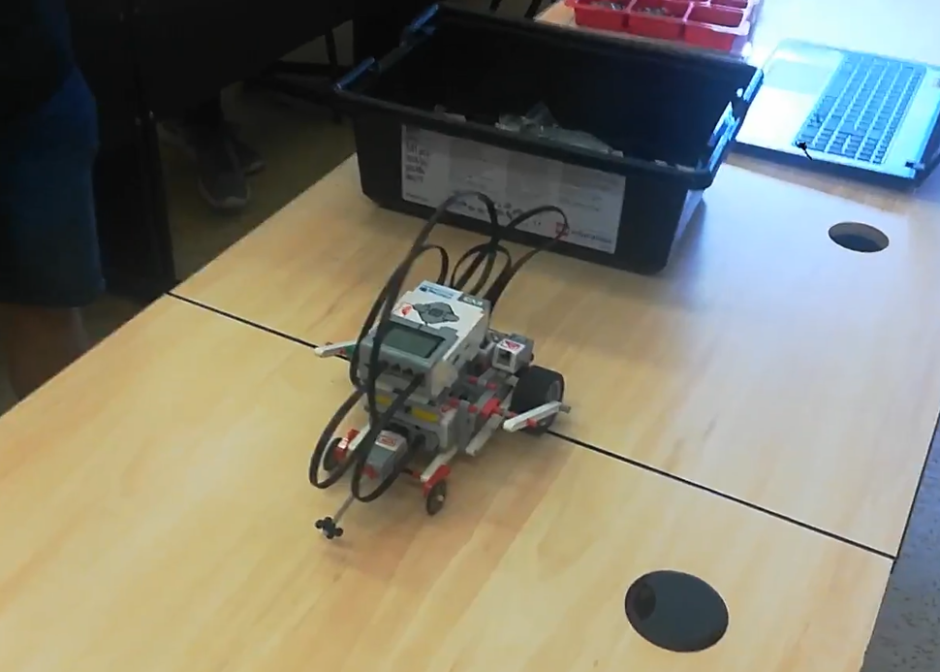
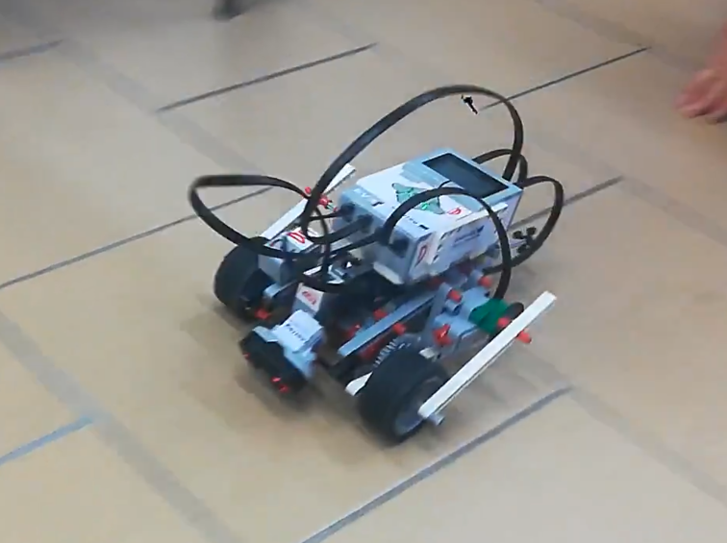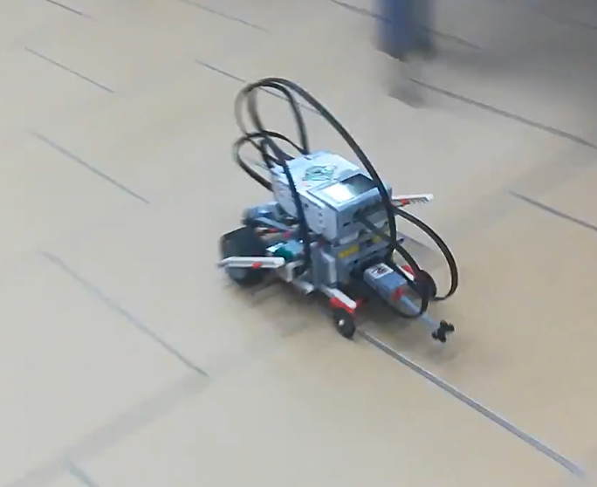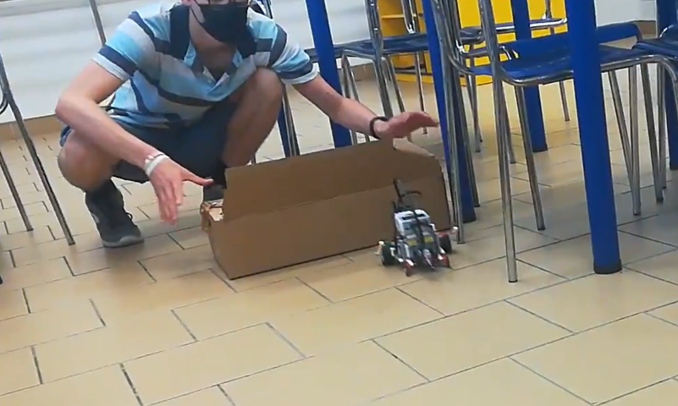

- Reconnaissance vehicle with fan. Take advantage of the third motor and use it as an additional fan or a better rotating radar. The settings will be similar to the motors settings.
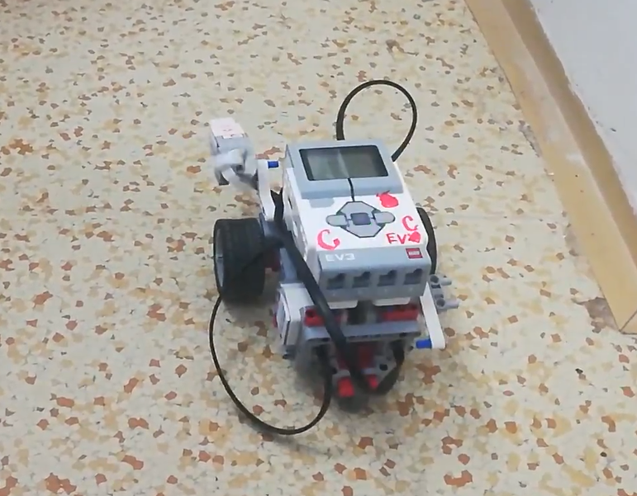

- Button-controlled buildings
  - Build both a car and a motorbike and control them using the buttons on the SmartBrick. We also managed to build a crane, but this construction took too much time, which we didn't have in a classic computer science lesson.

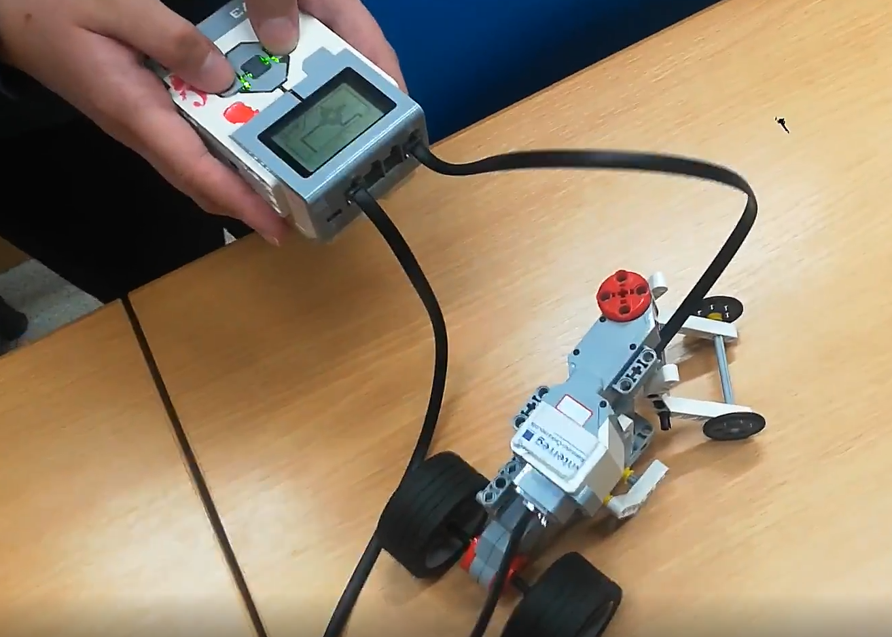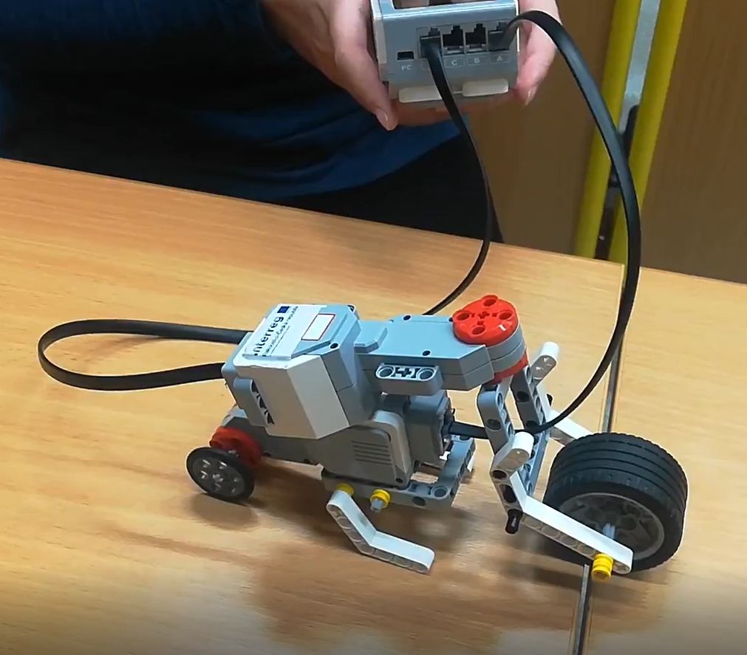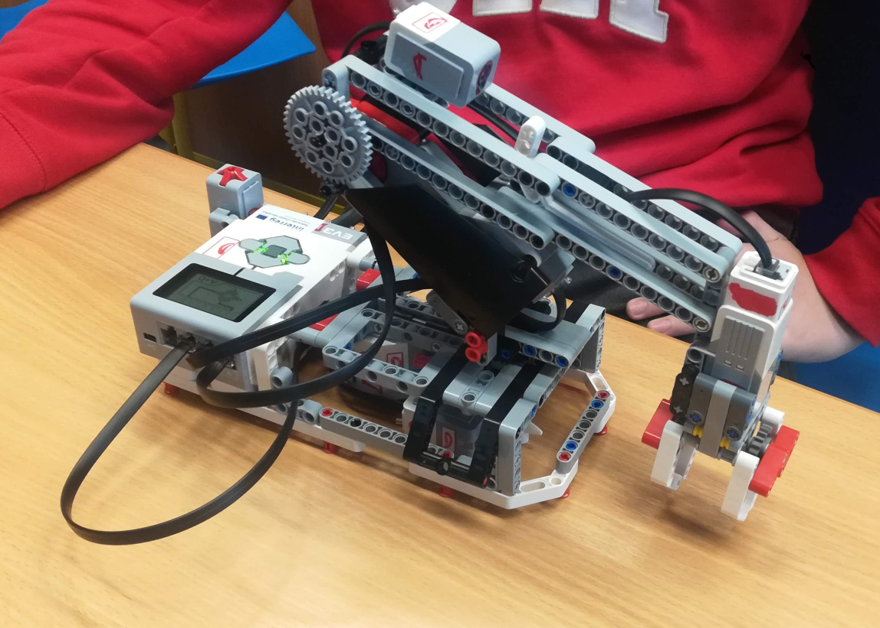

- Driving the robot along the line – The students have the task of programming the robot so that it can always stay on the drawn line using its two sensors. The principle is simple, if the colour sensor detects black, it slows down the rotation of the diagonally located wheel.
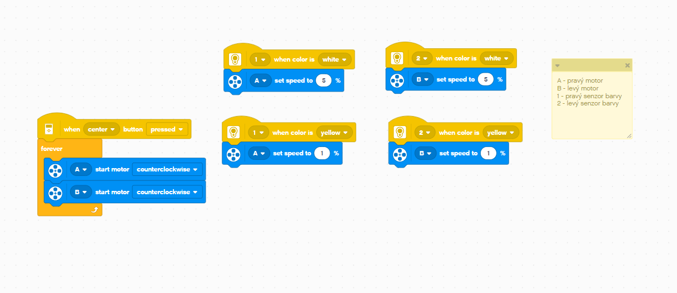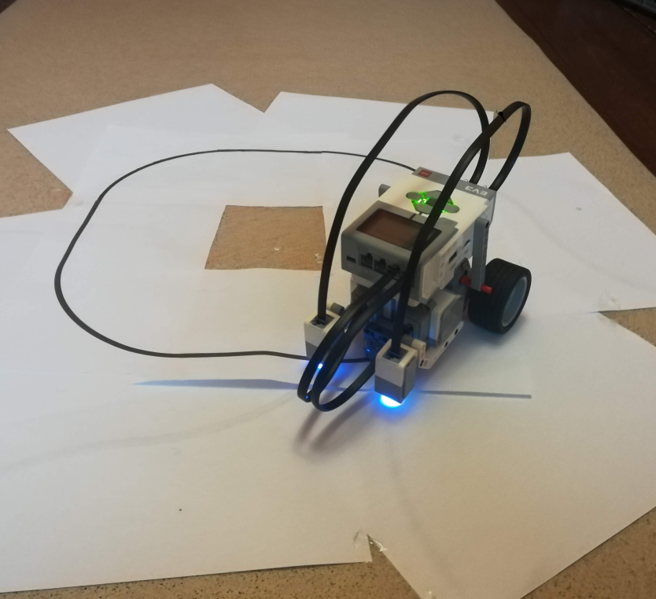

Conclusion

From our point of view, the whole project was a success. We have familiarised ourselves with robotic kits and believe that we have managed to select a number of simple activities that can be the first entry into robotics. Especially with lego EV3, I tried to achieve simple tasks that can be completed within a 45 minute class. After the students have mastered these simple tasks, they can then move onto more difficult types of constructions, which are listed in the manuals for LEGO EV3. We are glad to have been given the opportunity to participate in this project. In the future, if the project was to be repeated, better preparation of topics is needed on our part, for example, we could better connect the teaching of physics and robotics. In the future, we must also work on more efficient use of the options provided by LEGO EV3 in particular. In this project, we gave a lot of priority to motors and their connection with a distance sensor or a button. In the future, we could focus more on the use of additional sensors and the capabilities of the SmartBrick itself.
This project became a stepping stone for our school and teachers to get to know technology, its possibilities and pitfalls. Thank you for the opportunity to participate in the event and thus take robotics and informatics at our school to a new level.

